**Aim**

To design and deploy a **hospital appointment booking application** on a cloud platform (Zoho Creator) to demonstrate **Software as a Service (SaaS)**.

**Procedure**

1. **Login to Zoho Creator**
   * Open Zoho Creator and sign in with your Zoho account.
2. **Create a New Application**
   * Click **Create Application → From Scratch**.
   * Name it: **Hospital Appointment System**.
3. **Design Forms (Input Screens)**
   * Create a **Patient Registration Form** with fields:
     + Patient Name (Text)
     + Age (Number)
     + Gender (Dropdown)
     + Contact Number (Phone)
   * Create an **Appointment Booking Form** with fields:
     + Patient Name (Lookup from Patient Registration)
     + Doctor Name (Dropdown: e.g., Cardiologist, Dentist, General Physician)
     + Date (Date Picker)
     + Time (Time Picker)
4. **Add Reports (Views)**
   * Create a **Report Table** to list all appointments.
   * Apply filters so doctors can see only their appointments.
5. **Add Workflow (Optional)**
   * Use Zoho Deluge script to send an email/SMS confirmation when a patient books an appointment

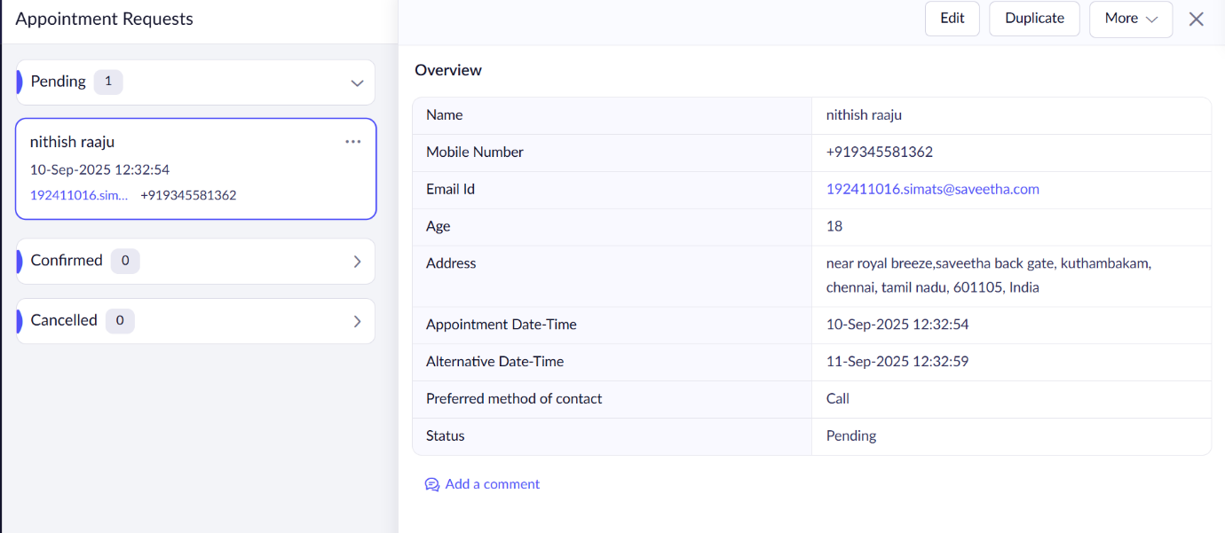

**Result**

* The **Hospital Appointment SaaS Application** was successfully created and deployed on **Zoho Creator**.
* Patients can register, book appointments with doctors, and receive confirmations.
* Doctors can log in to view their upcoming appointments.
* The system is hosted on Zoho’s cloud platform, accessible globally via the internet, demonstrating **SaaS (Software as a Service)**.